Full Name: Sumilhig, Paul Brian M Date: 31/10/2025
Subject/Section: SSYADD-SS231
Group Name: ALT_RUN
Project Name: E-ksena

Link to Openproject Board: | Link |
Openproject Board screenshot
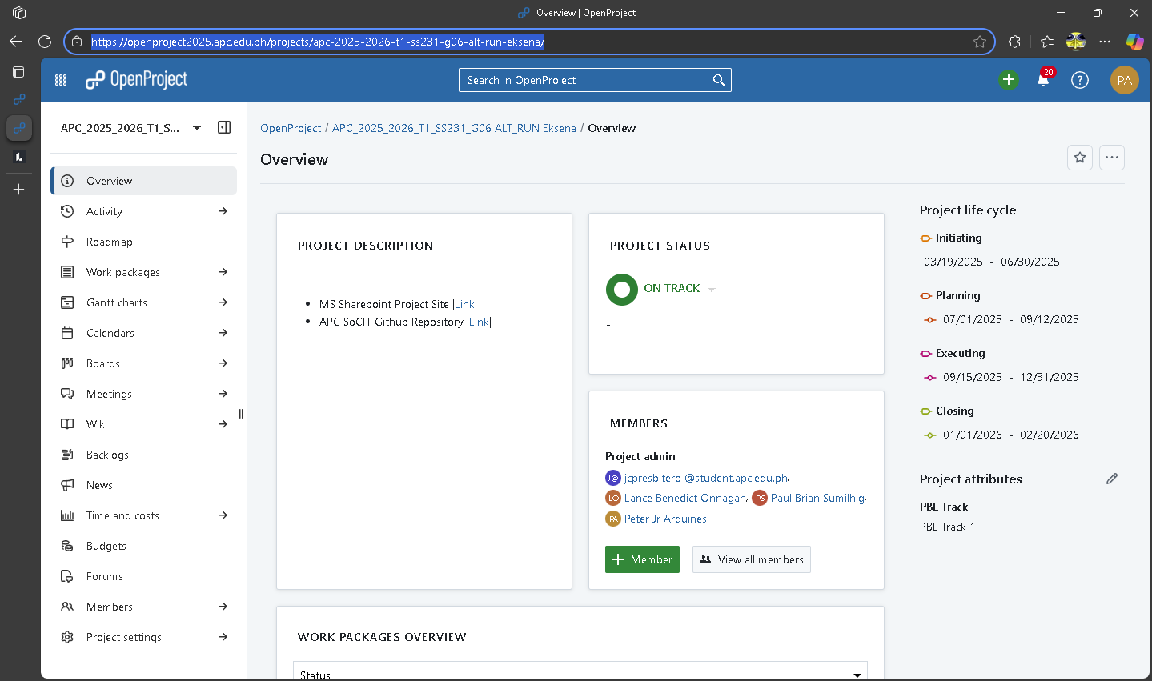
Screenshot of individual contribution of Entities to the ERD
Making the UCD
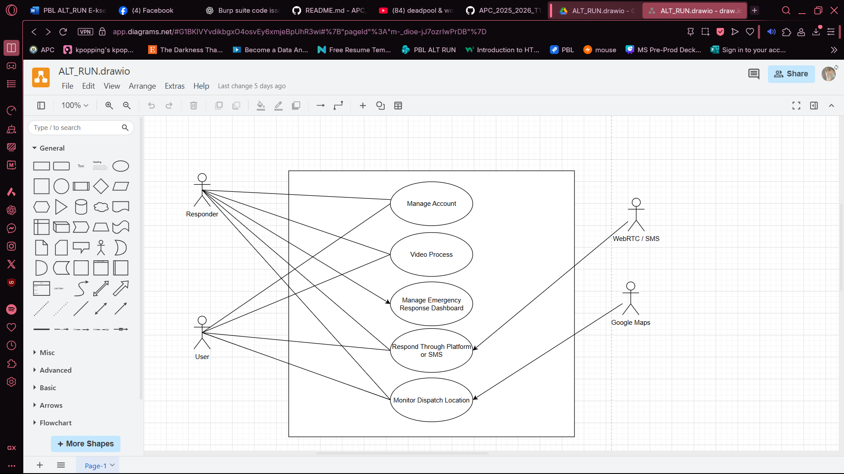

Figure 1. Use Case Diagram
Link to the Use Case Diagram |Link|
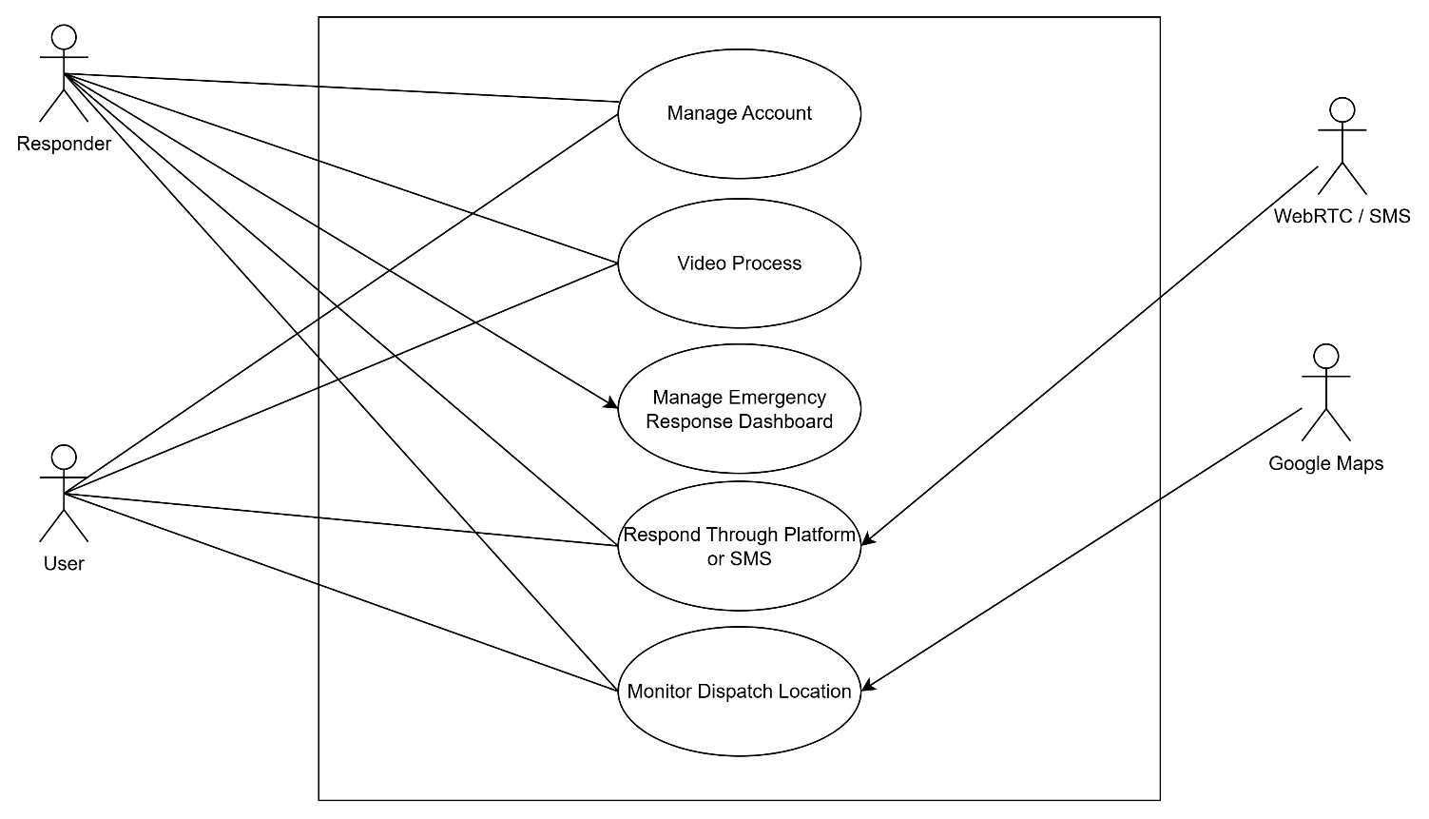

Hours estimated: 1 hour
Hours spent: 43 minutes

